Logo Exploration

A Logo is a visual identity for your Brand, which helps us communicate with the various aspects of the Brand, the product of service you provide to the internal team, vendors, consumers and general public.

A Logo is the face of the Brand and helps create a significant impression in the minds of the viewer. This subsequently evolves into creating a connection between the Logo and the experience you provide in your brand.

Logo Questionnaire

Your Name:
Brand Name:
e-mail id:
Contact Number:

Select your business category?
Professional Services
Financial Services
Real Estate
Sports & Fitness
Medical & Health Care Technology
Health & Beauty
Religious/Spiritual Organizations
Construction
Pets & Animals
Music & Arts
Food & Beverage
Non Profit
Travel & Tourism Wedding & Event Planning Child Care
Education & Training Energy & Environment Merchandise
Fashion
Other:

If you have any tagline?
Please mention here :

Project type?
New Design or Re-Design

No of Decision Makers in Logo Approval?
1
2
2+

Decision Makers' Contact Details * (Name - Designation - Contact No - email)

Logo Presentation Style?
Corporate
Typography
Minimalistic
Funky
Artistic
Other
If Other: Please Add Image or Link

Do you have any specific image, icons or logo, that you wish or do not wish to be in your logo? (If Yes Provide link or Image)

Where your new logo will be used?
Print
Website
App
Video
Others - Pls mention here :

Logo Type :
Self-explanatory
Conceptual / Explanatory

Logo Trends :
Kindly Select Any 3 from the samples given below
1.
2.
3.

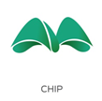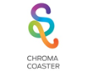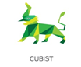
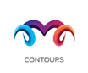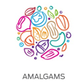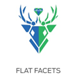

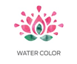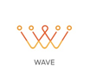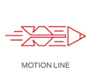
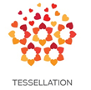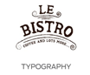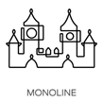

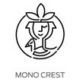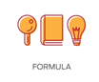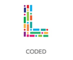

Do you have any color preference?
Kindly mention here:

What attributes of your business would you like your Logo to Reflect?
(Ex : Premium / Traditional / Funky / Classic)

What method of consultancy do you expect from us?

A. Personal Standard / Client Preference: Client may have a specific shape/concept in mind and would want us to create it for them.
B. Industry Standard – As per standards already prevailing in the industry.
C. Creative/Artistic – It is experimental and complete creative freedom is given to designer.

Who are your main competitors?
Please list their websites/Information here:

Please supply a brief description of the design you have in your mind any other information that would be useful?

Any specific Do’ and Don’t’s you would like to share with us?

